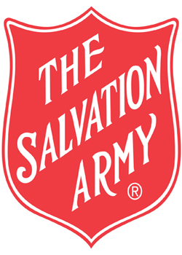
THE SALVATION ARMY - RECOVERY SERVICES FIJI
AOD CASEWORKER POSITION DESCRIPTION
Location: Suva, Fiji
Reports To: Recovery Services Team Leader
Service: The Salvation Army Recovery Services Fiji (RSF)

Position Purpose
To provide trauma-informed, culturally responsive Alcohol and Other Drug (AOD) case management, recovery support, counselling interventions, advocacy and care coordination for individuals and families affected by substance use. The role supports recovery, harm reduction, community reintegration and improved wellbeing across Fiji.

Key Responsibilities
- Conduct comprehensive AOD screening, assessment and risk assessments.
- Develop and implement individual recovery and case management plans.
- Provide motivational interviewing, relapse prevention, and recovery-focused interventions.
- Maintain regular client contact and monitor progress toward recovery goals.
- Coordinate referrals to health, mental health, housing, employment, and social support services.
- Facilitate psychoeducational, therapeutic, and recovery support groups.
- Participate in outreach activities across urban, rural, and maritime communities as required.
- Maintain accurate and confidential client records and reporting.

Fiji-Specific AOD Responsibilities
- Provide support to individuals affected by alcohol, methamphetamine (ice), cannabis, inhalants, kava misuse, prescription medication misuse and other emerging substance issues in Fiji.
- Work collaboratively with the Ministry of Health and Medical Services, Fiji Police Force, Fiji Corrections Service, hospitals, welfare agencies, churches and community organizations.
- Support court-referred, police-referred, and voluntary clients.
- Deliver culturally responsive services for iTaukei, Indo-Fijian and other communities.
- Assist with community awareness, prevention and stigma reduction initiatives throughout Fiji.
- Support family engagement and recovery planning where appropriate.
- Contribute to service development, program evaluation and donor reporting requirements.
- Assist with collection of service outcomes and program data.

Professional Practice
- Work within trauma-informed, recovery-oriented and person-centered practice frameworks.
- Participate in supervision, team meetings, and professional development.
- Uphold The Salvation Army mission, values and code of conduct.

Essential Requirements
- Degree, diploma or equivalent qualification in Social Work, Counselling, Psychology, Community Services, Public Health or related field.
- Experience working in AOD, mental health, social services, or community services.
- Strong communication, assessment, and case management skills.
- Current driver license and ability to travel within Fiji when required.
- Ability to maintain professional boundaries, confidentiality, and accurate documentation.

